CHAPTER 2 THEORIES AND LITERATURE REVIEW

This chapter provides an overview of key theories and research related to Intrinsic optical properties, PDMS, Laser, Integrating sphere,

2.1 Intrinsic Optical Properties of human bone
Stents are a type of prosthesis with a small cylindrical structure that is inserted into the affected region via a catheter [37].The primary purpose of a stent is to provide structural

2.2 Laser 850 nm
Stents are a type of prosthesis with a small cylindrical structure that is inserted into the affected region via a catheter [37].The primary purpose of a stent is to provide structural

2.3 PDMS
Stents are a type of prosthesis with a small cylindrical structure that is inserted into the affected region via a catheter [37].The primary purpose of a stent is to provide structural

2.4 Integrating Sphere Measurement System
Stents are a type of prosthesis with a small cylindrical structure that is inserted into the affected region via a catheter [37].The primary purpose of a stent is to provide structural

Single double example theory and measurement type

2.5 Inverse Adding-Doubling (IAD) Method
Inverse Adding-Doubling (IAD) method has been used in biomedical optics research to determine the optical properties of skin, brain tissue, skeletal muscle, cranial bone and tissue phantoms across the visible and near-infrared spectral regions from experimental measurement of diffuse transmittance and diffuse reflectance [2 example that iad is used paper]. The main advantages of IAD method are that it does not rely on the diffusion approximation which is inaccurate for thin samples, and it offers a significant computational advantage because it provides deterministic solutions and faster convergence, while maintaining the comparable accuracy with Mote Carlo method [phal papermonte carlo].
{need to add two example usage}
The IAD method is based on solving the one-dimensional radiative transfer equation (RTE) by using the adding-doubling (AD) algorithm which is developed by [phal and authoer]. IAD method starts by estimating the initial absorption coefficients, $μ_{a}$,and reduced scattering coefficients, $μ_{s}^{'}$. Then those approximated values are supplied to the forward adding-doubling algorithm, which computes the theoretical values of reflectance and transmittance by solving the RTE. The computed values are compared with the experimentally measured diffuse reflectance and transmittance of a homogeneous slab samples of known thickness and refractive index. The convergence can be achieved rapidly as the forward solution is numerically stable. The anisotropy factor g is assumed by using the Henyey-Greenstein phase function. [Phal Paper]
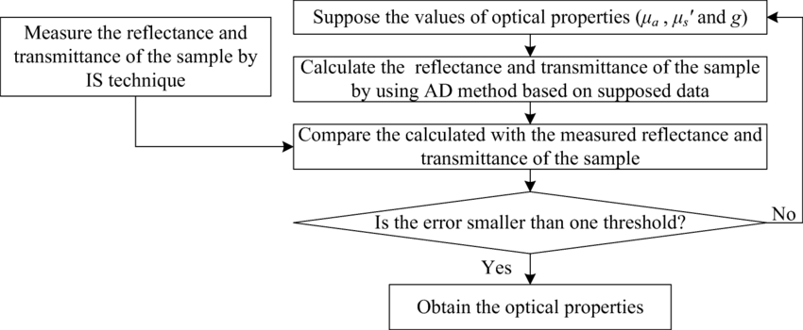
Fig. Inverse Adding-Doubling Method [Draw by your self]

2.5.1 Radiative Transport Equation (RTE)
The Radiative Transport equation (RTE) describes how light moves inside a scattering medium which describes as: [find paper]
$$\frac{1}{v}\frac{∂\text{L(r,}\hat{\text{Ω}}\text{,t) }}{∂t}=-\hat{\text{Ω}}.∇\text{L(r,}\hat{\text{Ω}}\text{,t)}-μ_{t}\text{L(r,}\hat{\text{Ω}}\text{,t)}+μ_{s}\int_{4π}{\text{L(r,}\hat{\text{Ω}}\text{,t)p(r,}{\hat{\text{Ω}}}^{'}→ \hat{\text{Ω}}\text{)}d{\hat{\text{Ω}}}^{'}+\text{Q(r,}\hat{\text{Ω}}\text{,t)}}$$
Where:
$\text{μ} \frac{\text{​}\text{∂L(z,}\text{μ)}}{\text{∂}\text{z}}=\text{-} \text{(}{ \text{μ}}_{a }\text{​+}{ \text{μ}}_{s }\text{​) }\text{+}{ \text{μ}}_{s }\int_{-1}^{1}{\text{p(}\text{μ,μ')}\text{L(z,}\text{μ')} \frac{\text{d}\text{μ'}}{2}\text{​} }$ ​​
    - $\text{L(z,}\text{μ)}\text{ =}$ radiance
    - ${ \text{μ}}_{a }$= absorption coefficient
    - ${ \text{μ}}_{s }$= scattering coefficient
    - $\text{p(}\text{μ,μ')}$ = phase function (Henyey-Greenstein)
    - g = anisotropy (average cosine of scattering angle)

2.5.2 Henyey-Greenstein Phase function
The Henyey-Greenstein Phase function is from phal [paper 4 in iad folder ]
[Phase Function] and find paper

